Address Book Application

Functional Spec

# Introduction

The Address Book application is a simple one page web application that will contain individual’s contact information. It will allow people to search for other individuals based on several different criteria (names, addresses, phone numbers, etc…) Also, if anyone notices any discrepancies, they can modify information. New people can be added to the system by anybody (there will be no authentication and authorization) and anyone can be deleted from the system.

# Not Included

The following features will not be included in this release:

* Login

# User Walkthrough

Alice is an employee at CompanyOne and needs to keep in contact with other employees, as well as outside contacts. However, Alice has troubles with remembering phone numbers, email addresses and physical address of people she corresponds with. In order to help her with this problem she regularly uses the company’s address book application that stores this information for her and allows her to search for different contacts. In order to use the application she points her web browser to the address book URL and is presented with the initial screen:

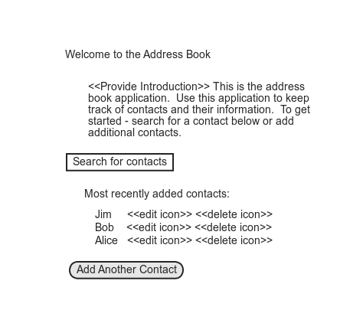

*Figure 1: Initial Page*

As Alice starts to type in information in the ‘Search for contacts’ field, the ‘Most recently added contacts:’ field changes to ‘Found contacts:’ and the list of people gets updated to match the filter. Each name that is displayed under the contacts can be clicked on that will bring up another frame with all known contact information filed in. Inside of this box, information can be viewed, updated, deleted, or the whole contact may be deleted from the system:

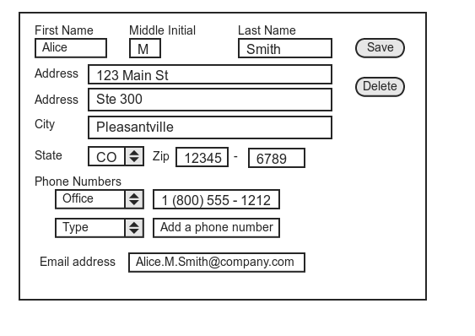

*Figure 2: Editable contact information*

Alice can make any change to any field, and by clicking on the ‘Save’ button those changes will be updated. If she clicks on the ‘Delete’ button then the contact will be removed from the system (after asking for and receiving confirmation that this is what she wants to do.)

From the main page, if Alice wanted to add an additional contact, the same form as shown in ‘Figure 2’ would be displayed.